
YALE NEW HAVEN HEALTH
AMBULATORY EXPANSION 2026


ARCHITECT PROJECT NUMBER
THE S/L/A/M COLLABORATIVE 25195.20
80 GLASTONBURY BOULEVARD
GLASTONBURY, CONNECTICUT 06033

Add - 789 Howard Avenue​​​, New Haven​​​.
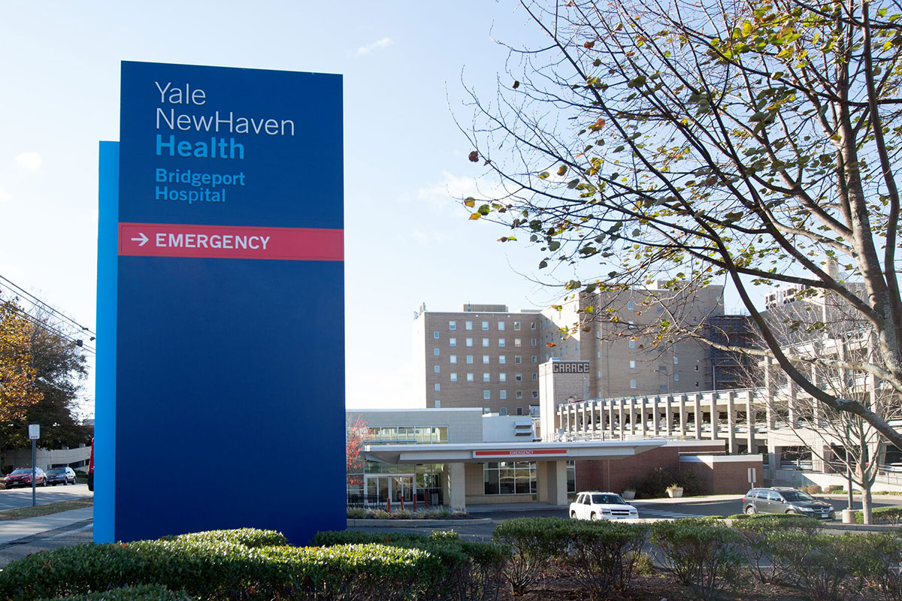

PROJECT SCOPE:
The scope of the project is the renovation of several areas of the property identified on the drawing package or packages issued with this specification.
Project: Northeast Medical Group (YNHH) Ambulatory Expansion, 440 Mamaroneck Ave, Harrison, NY (Suite 301). The project is a renovation and expansion of an outpatient medical clinic on the 3rd floor.
Key Observations
- Existing healthcare facility remains operational during construction; phasing, infection control, and life-safety measures are critical.
- Occupancy classification is Group B (Business) with an occupant load of 81 persons on the project floor and total exit capacity of 393 persons.
- Designed in compliance with 2025 NY State codes, ADA, NFPA 101, and FGI healthcare guidelines.
- Significant demolition includes removal of partitions, doors, ceilings, flooring, glazing, and casework before reconstruction.
- Strong emphasis on accessibility, fire protection, infection control, and maintaining hospital operations during renovation.

Door Schedule Summary
There is total 42 opening modes, including SGL, PR, and DA. Three openings with aluminium door material are excluded.
General Door Requirements
- Most doors are 3'-0" wide × 7'-0" high.
- Door thickness: 1-3/4".
- Majority are solid-core wood doors in hollow metal frames.
- Standard door undercut: 5/8 inch.
- Hardware per Division 08 specifications.
Door Types Used
- F = Flush Wood Door
- FG = Full Glass Door
- Existing doors reused in some locations
- Hollow Metal (HM) frames throughout clinic

Special Door Features
- Automatic entrance doors at Registration/Waiting Area
- Card Reader (CR) access-control doors
- Double-acting door at toilet locations
- Access-control integration with fire alarm system
- Automatic door operators at key public entrances

Wall & Partition Summary
- Metal stud partitions with gypsum board.
- Sound-rated partitions:
  - STC 48
  - STC 53
- Fire/smoke-rated partitions required in designated locations.
- Moisture-resistant gypsum board used in toilets and wet rooms.
- Firestopping required at all penetrations.

Overall Assessment
The project is a comprehensive outpatient clinic renovation and expansion focused on increasing exam capacity, improving staff workflow, modernizing MEP systems, improving patient experience, and ensuring full ADA, healthcare, and life-safety compliance. Key risks and coordination points are phased demolition, infection control, access-control integration, sprinkler/fire alarm modifications, and maintaining clinic operations during construction.

